CD player with MP3 and FM & Bluetooth and RS-232
FTD-25CD

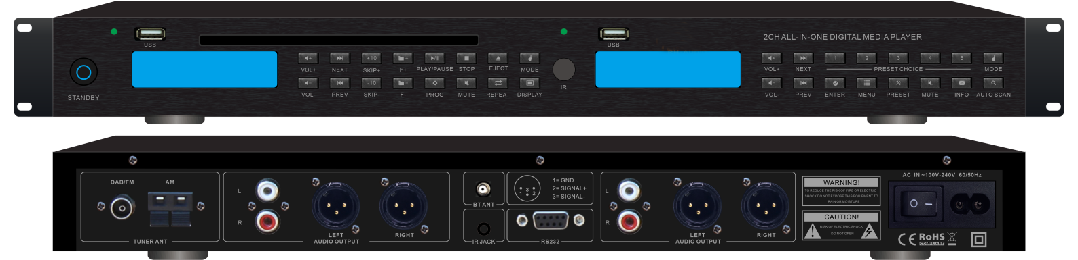

Features:

- 1U Height 19” rack mount design.
- BT/CD/FM/MP3 Four in one audio sources player.
- Music player with CD, Mp3 and tuner and bluetooth.
- Dual LCD English display with blue back light.
- Support various audio formats includes CD, CDR, CDRW, Mp3 & WMA.
- Mp3 player with USB input on front panel.
- Tuner support AM, FM & RDS.
- Bluetooth is support, RS-232 is support
- Supplied with IR remote control.

Specifications:

Model | FTD-25CD
Description | CD/Mp3 Player with Tuner
Compatible media | Channel A: CD,USB,Bluetooth  Channel B: USB,Bluetooth,FM(RDS) ,AM
Input | CD slot in & USB& BT
Frequency Response | 20Hz-20KHz
S/N Ratio | 60dB
Pitch Adjustment | ±24%
Radio Frequency | FM: 87-108MHz  AM: 522-1620KHz
Power consumption | 30W (0.5W standby)
Dimension | 330(W)×267(D)×49(H)mm
Weight | 4.1kgs

